Sermon
preached on 14 June 2026
by Richard Shepley
Readings
Genesis 18:1-15
Romans 4:1-3, 23-25 and 5:1-8

We have heard two scripture readings and a Psalm. What can they teach us about the character of our God?
Let’s start with Abraham at the Oaks of Mamre. Here’s an early photograph(?)
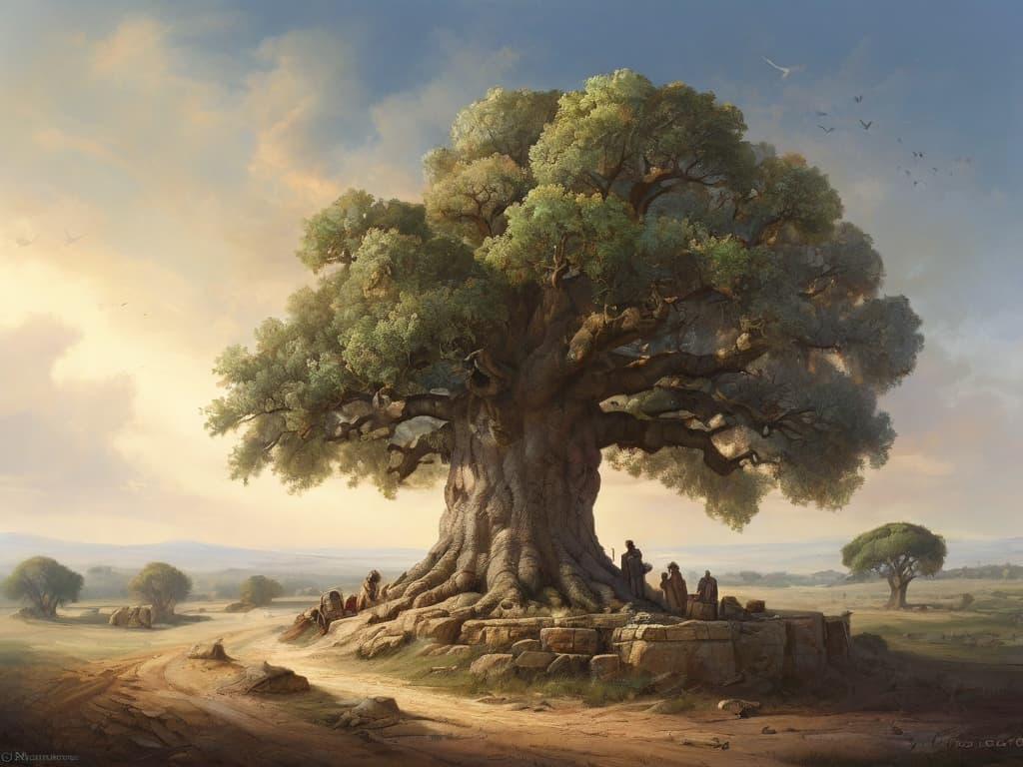
He is sitting outside his tent when three strangers come into view. In keeping with Eastern hospitality, he offers them shade, rest, and water. But Abraham soon senses these men are more than ordinary visitors. So he starts racing around to kill and roast a lamb and tells his wife Sarah, to bake bread “Quickly,”!!!
After they have eaten, one of the visitors asks for Sarah. On hearing she is in the tent, the man delivers an astounding prophecy: next year they are going to have a baby. Given that Abraham is over 100 years old and Sarah is not far behind, she giggles at the very thought. What follows is a bit of a pantomime. The man says, “Sarah giggled!” Sarah responds through the tent wall, “No I didn’t.” The man counters, “Oh yes you did!” Presumably the conversation went on in that vein for some time . . .
Why was Abraham living in the desert at Mamre, twenty miles south of where Jerusalem would eventually be? You may remember that, back in his hometown, he had heard a voice telling him to leave and go to Canaan, promising he would become the father of a great nation. He believed it was God, obeyed, and now this "Lord" tells him he will have a son. At last.
Abraham knew God was looking after him as he had promised. but did he know if God loved him?
We don’t know. And it isn't until about 350 years later that we find the first mention of God’s love in the Bible. In Deuteronomy 4:37, Moses tells the Israelites, “Because God loved your ancestors, he chose you their descendants after them.”
This understanding grew fuller and deeper over the generations. We heard it echoed in Psalm 100, when we proclaimed together:
"The Lord is good; his steadfast love endures for ever, and his faithfulness to all generations."
Through the centuries, the Prophets continued to reinforce the message to the people that God loved them, even in their disobedience.
Then, as we move into the New Testament, Jesus reveals a radically new understanding of divine love: that, as the Gospel of John tells us, “God so loved the world that he gave his only Son to die for us.”
St Paul, following his encounter with the risen Christ, spent three years alone and praying in the desert as he unpacked the implications of Jesus teachings and life, death and resurrection.
His letter to the Romans is the fullest declaration of his understanding. Paul explains that while Jewish teaching emphasized strict obedience to the law, God’s relationship with us operates differently; and he uses Abraham as his example of “justification” – in simple language that means being “made just” – or innocent.
"If Abraham was justified by works – what he did- he has something to boast about, but not before God. For what does the scripture say? ‘Abraham believed God, and it was reckoned to him as righteousness.’ ... Therefore, since we are justified by faith, we have peace with God through our Lord Jesus Christ."
Paul concludes with a powerful truth: "God proves his love for us in that while we still were sinners Christ died for us."
Does God really love us that much, or does He - as we often think – really only tolerate us?
Great modern preachers have ways of answering that question.
Sam Wells, Rector at St Martin-in-the-Fields,

His colleague, Richard Carter, puts it like this
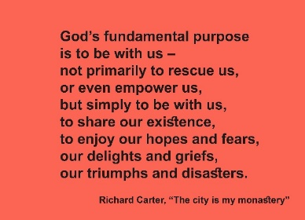
To be totally and deeply loved like this is the most basic requirement for a fulfilled life.
Knowing this truth can truly be transformational.
You might ask, "How does this relate to our modern world?" We face wars, seemingly insane political leaders, climate change, and extreme right agitation.
How can we be faithful Christians, with such pressures in such difficult times?
St. Paul lived in difficult times too. He told the Romans, “We boast in our hope of sharing the glory of God, but we also boast in our sufferings.”
The Bible never promises a pain-free life. Instead, it promises God’s constant presence through any suffering: “Even though I walk through the valley of the shadow of death, I will fear no evil; for you are with me.”
Thin Places
To help us experience this presence, there are so-called "Thin Places." Locations where the veil between the physical and spiritual dimensions is lifted.
The Oaks of Mamre were such a Thin Place. And have remained so for millennia; one of its ancient trees still stands today
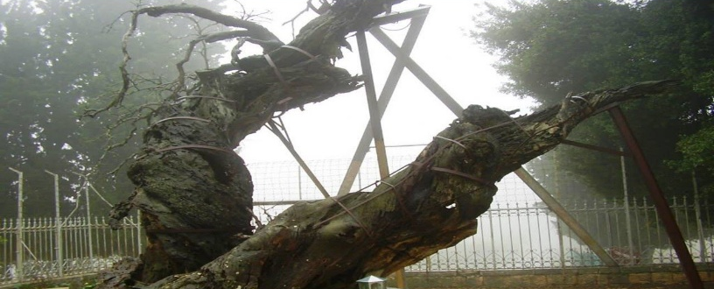
Though whether it still remains a place where the veil is thin is perhaps another matter!
Today, for many of us, a Thin Place can be found on Holy Island in Northumberland, or a favourite walking trail, an isolated beach, a quiet chapel in a cathedral.
However, we don’t always have to travel to find Thin Places. Fortunately, sometimes they will find us:
- Music for many of us can create a Thin Place. For me, listening to Schubert’s Piano Sonata No. 21 can make me especially aware of the presence of Jesus with me.
Pictures can do the same– especially ikons.
- Icons can bridge the gap and make a Thin Place.
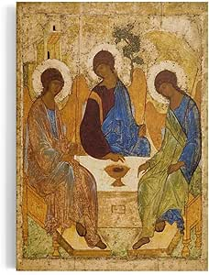
This is probably the most famous ikon in the world.
Who were those three guests at Mamre? Men? Angels? Or a theophany—a tangible manifestation of God? Abraham addresses them as Adoni, a Hebrew word for God which is interestingly plural.
Rublev paints them as the Trinity: Father, Son, and Holy Spirit.
The Father is the one on the right, who the Son and the Spirit are looking at. The Father looks back at them.
And this makes sense, because Love needs an object to love.
Their positioning creates a circle. That’s intentional. It’s the eternal movement of love within the Trinity, what the Church Fathers called perichoresis, the mutual indwelling of the three Persons.
And note that from where you are positioned looking at the ikon, there is a space at the table for you. The eternal love shared within the Trinity includes you. And me. All of us.
We all need to find Thin Places. When the world overwhelms us, they bring calm, restore balance, and anchor us in God’s eternally enduring love.
Amen.

